User Manual

T4C Gravity – v1.1.0

**Copyright**

© Copyright 2023 DH Healthcare GmbH. All rights reserved.

No parts of this document may be reproduced, copied, adapted or transmitted in any form or by any means without the written permission of DH Healthcare GmbH.

DH Healthcare GmbH reserves the right to make changes to this document without prior notice.

A printed version is available upon request.

This product is a trademark of Dedalus S.p.A., Italy or its affiliates. All other trademarks are held by their respective owners and are used in an editorial fashion with no intention of infringement.

 DH Healthcare GmbH, Konrad-Zuse-Platz 1-3, 53227 Bonn, Germany

In this product, user settings and functionalities are determined by configuration options and security settings.

This product can be modified to support the workflows and methods that are used in your hospital.

As a result, the functionalities and screen settings that are described in this document might differ from what you can do and from what you see on your screen. The settings can also differ from department to department.

**Statement on gender-neutral terminology**

For reasons of legibility and clarity, gender-neutral terminology is used, e.g. User. Corresponding terms apply equally to all sexes.

**Document history**

Latest update of this document: 17/01/2024

<https://my.dedalusportal.com>



**Table of contents**

1 T4C Gravity Portal - Introduction 5

1.1 Document instructions 5

1.2 Scope 5

1.3 Intended use 5

1.4 Indications for use 6

1.5 Statement of contra indications 6

1.6 Intended users 6

2 T4C Gravity setup 8

2.1 Login to T4C Portal 8

3 Home Page 10

3.1 Viewing Research details 10

4 Settings 12

4.1 Manage Gravity users 12

4.2 NLP score setup 15

4.3 Questionnaire 16

4.4 Field and Button Description – Settings page 17

5 Perform research query – Cohort Builder 19

5.1 Build a new query 19

5.2 View and use the previous query history 21

5.3 Modify and Save query research 22

5.4 Send the research for approval 24

5.5 Field and Button Description – Cohort Builder page 26

5.6 Field and Button Description – Send for approval in Cohort Builder page 28

6 Requests 29

6.1 Approve and reject the research 29

6.2 Field and Button description – Requests page 30

7 Research Page 31

7.1 Manage the specific research 31

7.2 Field and Button description – Research page 32

8 My Saved Cohorts page 34

8.1 Manage the specific research 34

8.2 Field and Button description – My Saved Cohorts page 38

9 Research History 40

9.1 Field and Button description – Research History page 40

10 Logs 42

10.1 Review internal organization history 42

10.2 Field and Button description – Logs page 43

11 Documentation 44

11.1 Field and Button description 44

12 References 46

12.1 Generic references 46

13 Appendix 48

13.1 Glossary 48

13.2 FAQ 48

14 Amendment History 49

# T4C Gravity Portal - Introduction

## Document instructions

This document contains information for the effective **operation and scope of Trials4Care (T4C) Gravity portal**.

## Scope

This document is valid for T4C Gravity portal version 1.1.0

## Intended use

The primary intended use of the **T4C platform** is to bridge the gap between the healthcare providers and the life science ecosystem by enabling researchers to more effectively search for suitable patients that match their trial criteria.

T4C Gravity portal securely links researchers and a dispersed pool of patients using a set of technologies, processes and systems that ensure patient data is shared safely, legally and ethically for secondary use.

**T4C Gravity** is a centralized research data network that aggregates metadata into the ‘Metadata Observatory’ (MDO) from disparate T4C Edge services.

MDO is a secure, scalable, data store that is optimized for search and indexing, and helps life science organizations quickly access reliable and high-quality data that is critical to a successful feasibility study. Data in MDO is presented through a secure data analytics platform that helps research organizations perform feasibility studies with the obscured data.

**Researchers** can also raise requests to collaborate further with the care provider(s) through a secure web application called T4C portal, without knowing the identity of the data provider and their patients.

T4C Gravity portal is an application where you can,

* Enter clinical trials’ inclusion/exclusion criteria,
* Build anonymized cohorts and send requests to potential sites for further collaboration and data sharing.

The goal is to assist with a trial process or simulation. T4C Gravity portal is primarily used to **create and send Expressions of Interest (EOI) requests** to Hospitals or other data provider organizations.

You can perform the following activities in the **T4C Gravity 1.1.0 version**:

* Set up the user role and access.
* Set up organisation level settings.
* Perform specific inclusion/exclusion criteria search.
* Create, manage and send EOI to potential sites.

For more information, contact Dedalus Healthcare.

The portal supports the recording of:

* User action audit and logs.

**Note:**

You can access the portal data from several locations in the right navigation panel.

## Indications for use

T4C Gravity portal enables connection of life science projects and data providers and allows to navigate the compliance steps and enter deep patient data sharing for the eligible project.

## Statement of contra indications

This document provides user guidance only on T4C Gravity portal and not any other T4C capabilities such as Analytics or the T4C Edge portal.

This portal is not intended to receive or send data to or from external applications except for the described ones.

Cohort information in the portal should only be used for study or site feasibility checks and to trigger Expressions of Interest workflows.

## Intended users

|  |  |
| --- | --- |
| Role | Permission |
| **Researcher** | User responsible for performing queries based on study inclusion/exclusion criteria and creating expressions of interest. |
| **Admin Researcher** | User responsible for creating a new user and reviewing, approving and sending an expression of interest to data providers. |

### Roles and Permissions

The various activities performed by Researcher and Admin Researcher as follows,

**Researcher:**

|  |  |
| --- | --- |
| Page | Action |
| **Home Page** | Overview of Recent research |
| **My Saved Cohorts** | View, edit, duplicate or delete an EOI |
| **Cohort Builder** | Perform a research query  Create an EOI |
| **Documentation** | Access to Guides and API references |

**Admin Researcher:**

|  |  |
| --- | --- |
| Page | Action |
| **Requests** | Approve/Reject a research |
| **Research** | Send, View, or delete an EOI |
| **Settings** | Create a user, edit user details, delete user and set NLP score. |
| **Research History** | Details about the EOIs sent. |
| **Logs** | View organization users’ actions |
| **Documentation** | Access to Guides and API references |

# T4C Gravity setup

The T4C Gravity first registration is done by the T4C team.

1. Check your **registered email**.
2. Click the **unique T4C link portal** set up page.
3. Set up your **user account** with **username.**
4. Create your **password**. It should include at least:
   * 1. Min - 8 characters length. Max – 64 characters length.
     2. One letter.
     3. One upper case
     4. One number.
     5. One special character (@%+\/' ! # $ ^ ?:.(){}[] ~-_).
5. Click **Submit.**
6. Click **OK in confirmation message** displayed.

Now you will be able to log in into T4C Gravity portal with your created credentials.

**Restriction:**

Organization ID is provided by default and not changeable.

## Login to T4C Portal

1. Go to **T4C Gravity portal**.

**Note:**

Always use the official URL provided by T4C team to avoid security credentials sharing risks.

1. Enter your **username**.
2. Enter your **password**.
3. Click **Sign In**.

**Restriction:**

Only existing users can login in T4C Gravity portal with the correct credentials (username/password).

Credentials such as email, username and password are unique and should be used only

by the registered user.

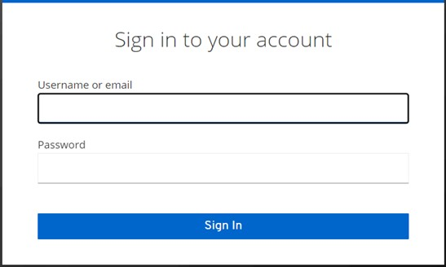

Login page

# Home Page

This page provides you the **Research details** such as **Recent Cohorts, Favourite Cohorts, Subscribed Cohorts**.

**Note:**

The **Home Page** is accessible to **Researcher** only.

## Viewing Research details

1. Click **Home** in the left menu of T4C Gravity portal; displays the **Home Page.**
2. In the Recent research field, click  to subscribe the research and click  to mark the research as favourite.
3. Click  to view all the research. Clicking view all will navigate to the **My Saved Cohorts page**.

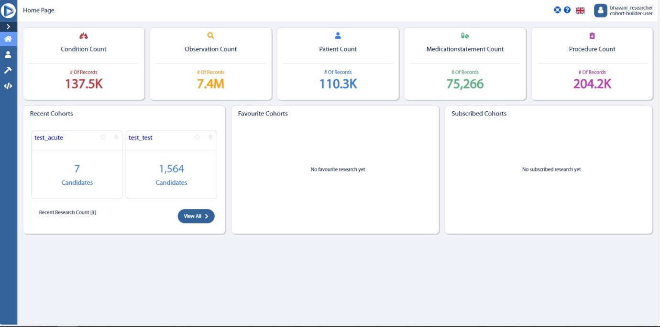

### Field and Button description

|  |  |
| --- | --- |
| Name | Description |
| **Condition Analytics** | Any problem, diagnosis or clinical concept identified in a patient. |
| **Medication Statement Analytics** | Drug or ingredient. |
| **Observation Analytics** | Vital signs, clinical findings and Laboratory data. |
| **Patient Analytics** | Demographic information to support administrative procedures. |
| **Procedure Analytics** | Any activity performed on the patient as part of provision of care. |
|  | |
| **Recent Cohorts** | Displays the research that made recently. |
|  | Navigates to the **My Saved Cohorts page** and displays the list of research made. |
| **Favourite Cohorts** | Displays the favourite research. |
| **Subscribed Cohorts** | Displays the subscribed research. |

# Settings

In the **Settings page,** you can **create a new user, edit user, delete user, setup the NLP score and Questionnaire**.

**Note:**

The **Settings** page is accessible to **Admin Researcher** only.

## Manage Gravity users

You can manage the T4C Gravity portal by logging in with Admin Researcher credentials and you can also perform the following activities:

* Create new user
* Edit user
* Delete user

### Create new user

You can create a new user in the **Admin Researcher** **Settings** page.

**Restriction:**

“Only **Admin Researcher** can create a new user”.

Refer**Roles and Permissions**for more information.

#### Creating a new user

1. Click **Settings** in the left menu of T4C Gravity portal; displays the **Settings page.**
2. Enter the **First Name, Last Name, Email, Username** for the new user in **New user setup box**.

**Restriction:**

This email address cannot be edited by the user and will be used for login and password resets.

1. Enter a **telephone number**.

Syntax: “0” + country code + phone number.

Example: 0 32 123456789

1. Select the **roles** according to the permissions defined in the Roles permissions. You can select one or multiple roles simultaneously.
2. Click **Save**.

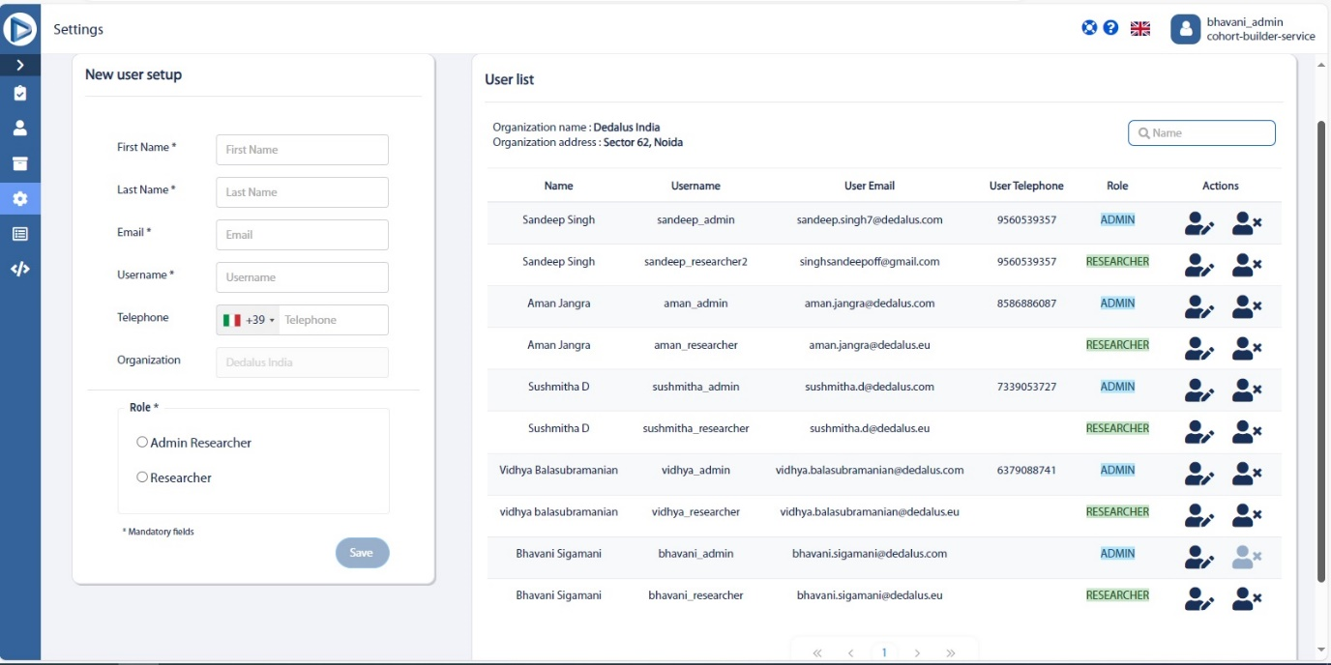

Settings page

### Edit user

You can **edit** the user information in the Admin Researcher Settings page.

#### Editing user

1. Click **Settings** in the left menu of T4C Gravity portal; displays the **Settings page.**
2. Click in the user list pane in **User management settings** page, displays the popup window where you can edit the user details such as **Name, Username, Telephone number, Email, Integrity checks (Minimum and Maximum number of allowed candidates).**
3. Click **Confirm** to save your changes.
4. Click **Cancel** to discard the changes.

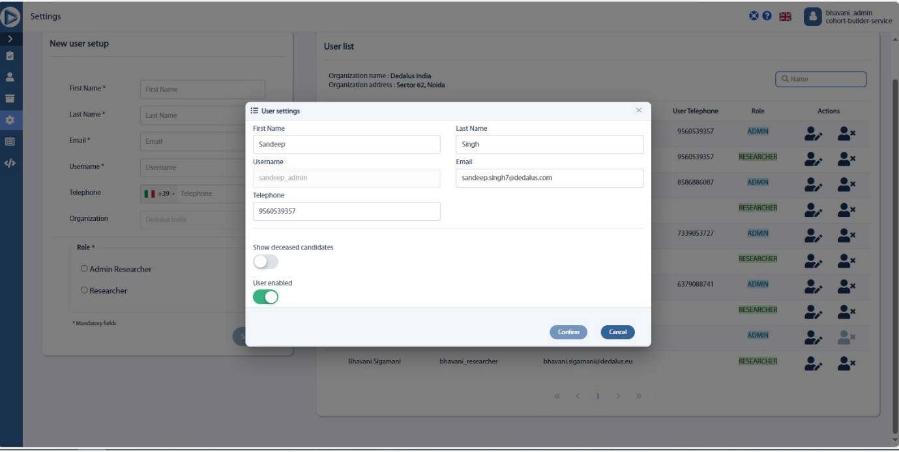

Figure: User management (Editing user in User list field)

### Delete user

You can also **delete** the user in the Admin Researcher Settings page.

#### Deleting a user

1. Click **Settings** in the left menu of T4C Gravity portal; displays the **Settings page.**
2. Click  in the user list pane in **User management settings** page, displays the popup window which has the following message,

***Are you sure you want to delete the user's registration?***

1. Click **Confirm** to delete the user.
2. Click **Cancel** to discard.

Figure: User management (Deleting user in User list field)

## NLP score setup

You can set up the **NLP score** based on your requirements.

The NLP confidence score indicates how sure the NLP model is that the correct entity recognition and normalisation has taken place.

There are three ranges of NLP confidence score, they are **High, Medium and Low**.

#### Setting NLP score

1. Click **Settings** in the left menu of T4C Gravity portal; displays the **Settings page.**
2. In the **Settings** page, NLP score setup; displays the **NLP Score setup**.
3. Set the NLP score based on your requirements.

**Note:**

The NLP confidence score should be set in the condition **High>Medium>Low.**

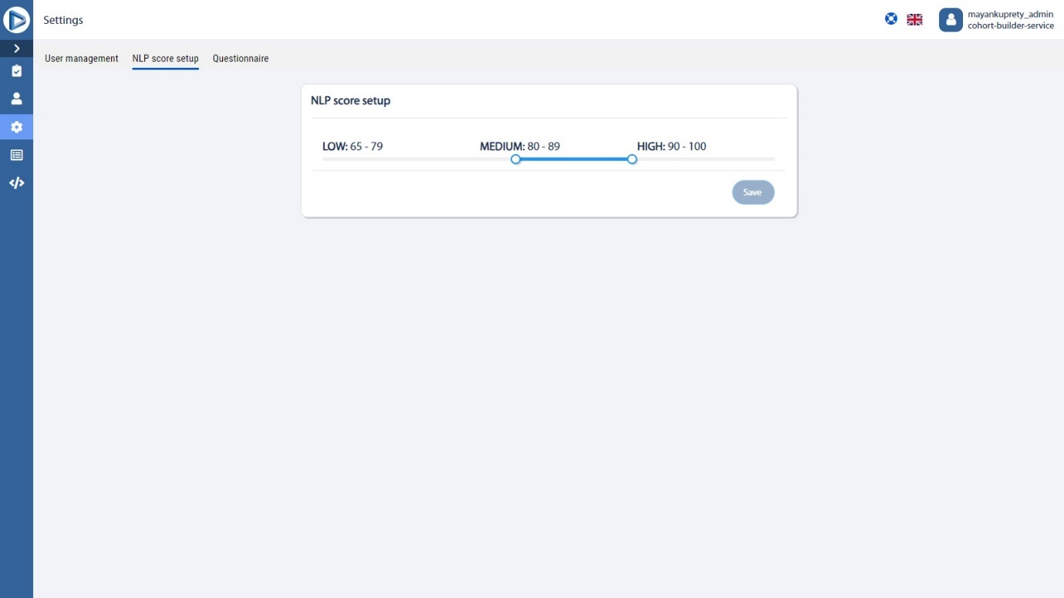

## Questionnaire

This section manages all the Questions required to send an EOI Request to a Hospital. This page contains some common questions required and you can also add a new question and set it as mandatory or not.

### Adding a new question

1. Click **Settings** in the left menu of T4C Gravity portal; displays the **Settings page.**
2. In the **Settings page**, click **Questionnaire**; displays the list of questions already added and allows you to add a new question.
3. Click the **Question field** and add a question.
4. Enable the **Mandatory** checkbox to set the question as mandatory or you can disable it if you do not want to make the question mandatory.
5. Click **Save** at the bottom to save your question.
6. Click  to **edit** the question.
7. Click  to **delete** the question.

## Field and Button Description – Settings page

|  |  |
| --- | --- |
| Name | Description |
| **User management tab** | |
| **New user setup section** | Allows you to create new user by providing **First Name, Last Name, Email, Username, Telephone, and Organization.** |
| **Role** | Allows you to select the role for the user such as **Researcher and Admin Researcher.** |
| **Save** | Saves the user details. |
|  | |
| **User list section** | Details of the user created such as **Organization name, Organization address, Name, User Email, User Telephone, Role and Actions.** |
| **Search** | Click to search for the user. |
| **Edit and Delete** | Clicking  allows you to edit the user and clicking  allows you to delete the user.  **Note:**  When you try to **Edit**, you will get the popup window that allows you to edit the user details. Click **Confirm** to make changes or click **Cancel** to discard the changes.  When you try to **Delete** a user, the following popup message will be displayed,  ***Are you sure you want to delete the user's registration?***  Click **Confirm** to delete the user or **Cancel** to discard the deletion. |
|  | |
| **NLP score setup tab** | Allows you to set the NLP score. |
|  | |
| **Questionnaire tab** | |
| **List section** | Displays the **list of questions** required to send an EOI to a hospital, **Mandatory or not**, **Actions** such as **edit and delete** the question. |
| **Question field** | This allows you to add a new Question and you can also make this question Mandatory or not by enabling the checkbox.  Click **Save** to save the question. |

# Perform research query – Cohort Builder

In the Cohort Builder page, as a researcher, you can perform the research queries based on your requirements. For example, if you want the list of patients who have been exposed or undergoing some medical issues like Covid-19, Cancer, Breast cancer, Asthma, etc, by using the conditions specifically.

**Note:**

The **Cohort Builder** page is accessible to **Researcher** only.

You can perform the following activities in the Cohort Builder page:

* Build new query
* View and use the previous history
* Save the research
* Send the research for approval

## Build a new query

You can build a new query in the Cohort Builder page that has lots of parameters which you can include or exclude by using **Inclusion/Exclusion criteria**. In the index dropdown, you can find the following conditions:

* Condition Analytics - Any problem, diagnosis or clinical concept identified in a patient.
* Medication Statement Analytics - Drug or ingredient.
* Observation Analytics - Vital signs, clinical findings, and Laboratory data.
* Patient Analytics - Demographic information to support administrative procedures.
* Procedure Analytics - Any activity performed on the patient as part of provision of care.

You can set the index based on your requirements for building a query.

### Building a new query

1. Click **Cohort Builder** in left menu of **T4C Gravity portal**; displays the Cohort Builder page.
2. In the **Cohort Selection Criteria**, click the **Include/Exclude** dropdown; displays the Include and Exclude options.
3. Click **Include or Exclude**,
   * 1. You can add multiple inclusion criteria.
     2. You can add multiple exclusion criteria.
     3. You can add inclusion and exclusion criteria's simultaneously.
4. In the **Index** dropdown, select the required parameter.
5. Select the **specific tag** from the possible tags available.
6. You can also select the gender by clicking **Gender** dropdown in the **Candidate Gender** field.
7. In the **Candidate Age Range** field, you can set the minimum and maximum age values.
8. In the **Candidate Age** field, you can set the specific age of the patients for the search.

The maximum age value is set as 95, therefore if you enter the value greater than 95 then the **Launch query** will be disabled and the following message will be displayed,

***No results to show for values greater than 95 as per GDPR policy***

1. Click **Launch query**; query results will be displayed with the federated data as the pie chart with **Country, Site, Gender and Age distribution.**

The below warning message will be displayed if the result count is less than 50,

***Due to data privacy, specific details cannot be displayed as the result count falls below 50. However, you can still proceed to send the Cohort.***

1. Click **Show Details** to view the detailed cohort result.
2. In the query results, you can
   1. Click  to **delete** the entire lane,
   2. Click  to **Enable/disable** the entire lane.
   3. Click  to **Add inclusion criteria** to query.
   4. Click to **Add exclusion criteria** to query.

Inside the grey field of the lane, cards displayed represent each criterion.

1. Click **Clear Criteria** to clear the current selection criteria set.

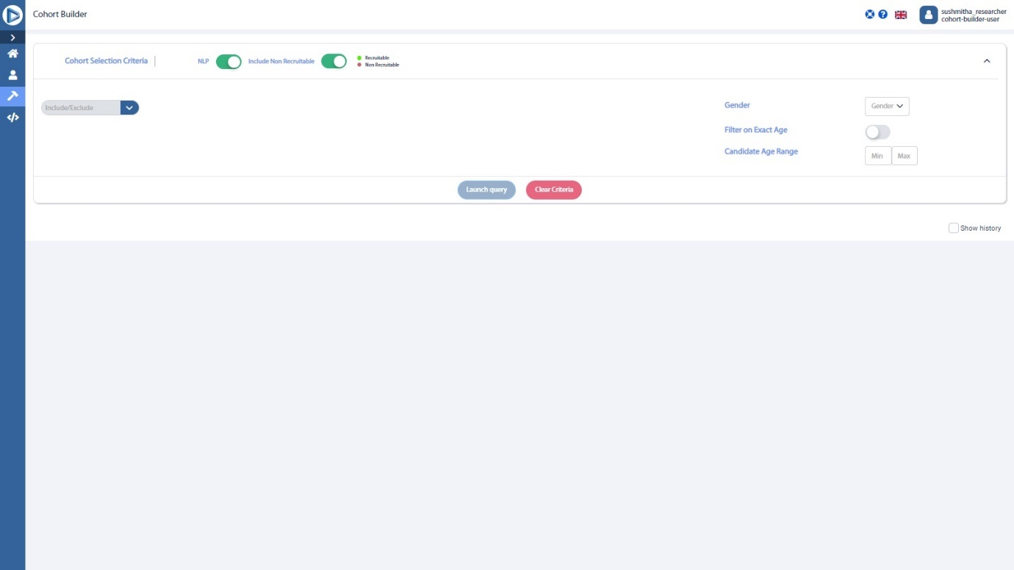

Cohort Builder page

## View and use the previous query history

You can view the previous query history and use any of the query by restoring it.

### Viewing and using the previous query history

1. In the **Cohort Builder page**; under the query results, click **Show history** below the Launch query button.
2. On the right, you will find the **Query history** with specific information like date, query results, conditions applied and username.
3. Click **Restore** to view the chosen query search in Cohort Builder page.

Previous history details

## Modify and Save query research

After launching your query, the results will be displayed and the portal will start fetching the federated data also, once the federated data is fetched, the overall query results will be displayed. Now, you can modify the query research if needed and save the query research and also keep the research queries as draft.

### Modifying and Saving query research

1. In the **Cohort Builder page**; above the cohort results; click Modify to modify your research query if needed.
2. In the **Cohort Builder page**; above the cohort results; click **Save** to save your research queries.
3. Complete the specifications of the research.
4. Click **Save**.

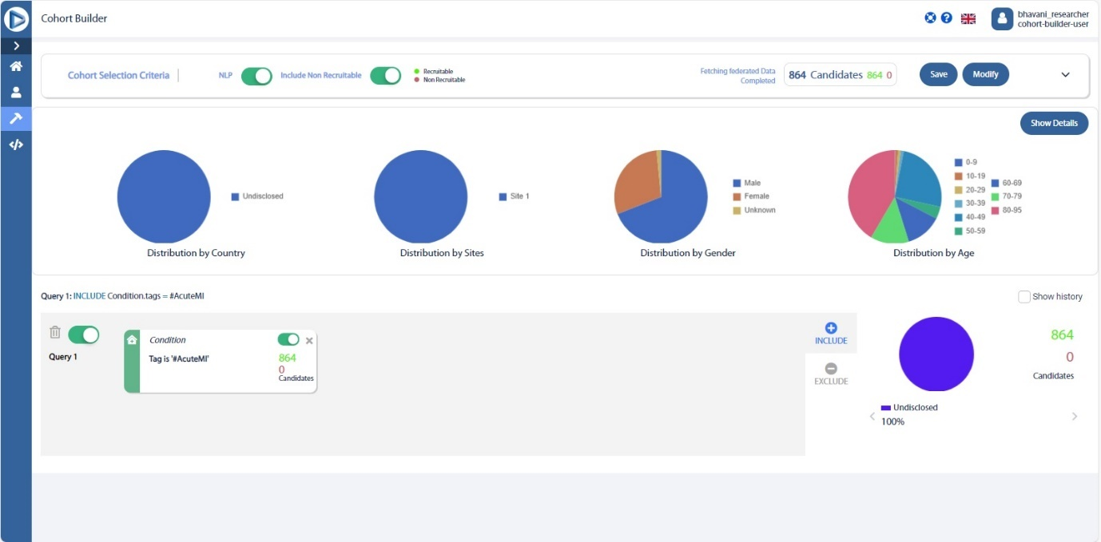

Fetching the federated data

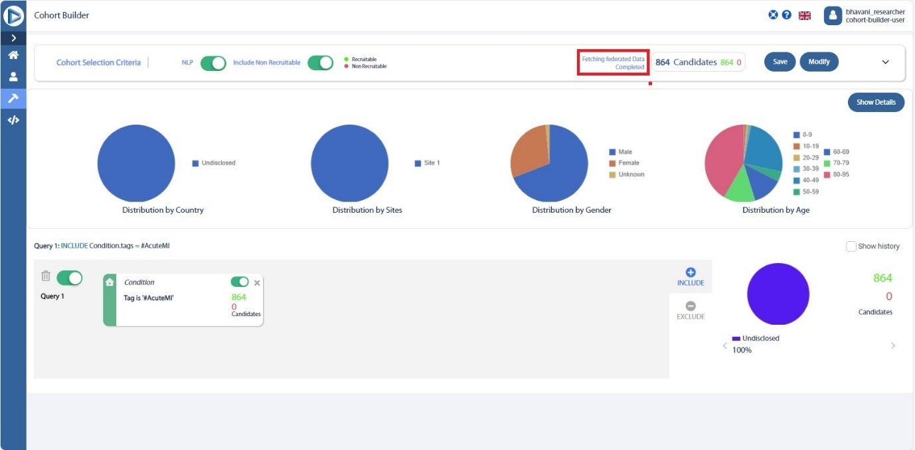

Fetching federated data completed

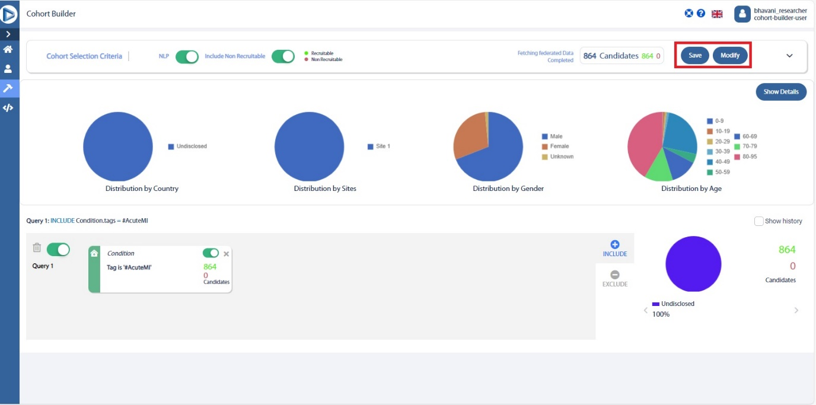

Save and Modify research

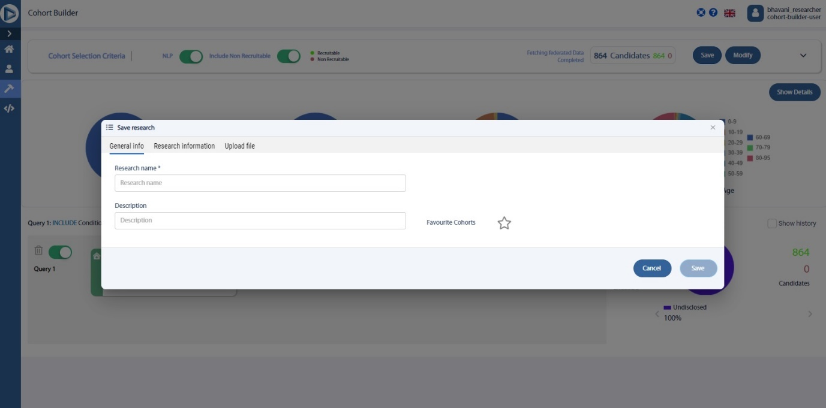

Saving research

## Send the research for approval

After saving the research, you will be redirected to the Summary page to send the research for approval, where the Summary page displays the count of Recruitable patients, Geographical distribution, Integrity checks and Research information questions.

### Sending the research for approval

1. After answering the list of Research information questions, click **Send for approval** at the bottom of the Summary page; displays the popup window which has the following message,

***Are you sure you want to send this Research for approval?***

1. Click **Send,** the research will be sent for approval.

Summary Page

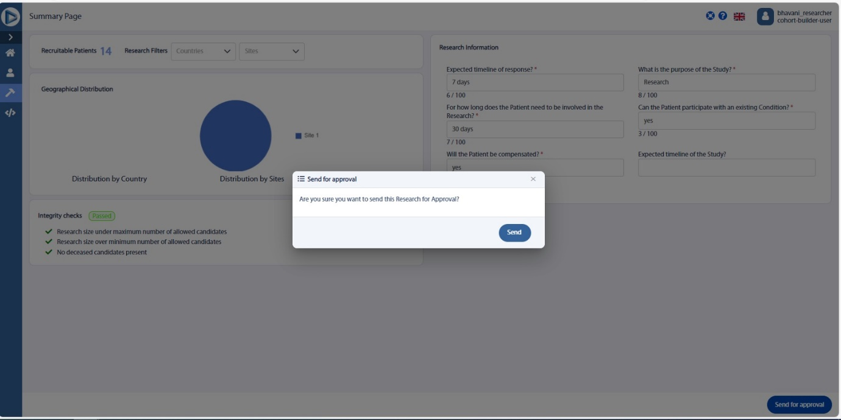

Sending the research for approval

## Field and Button Description – Cohort Builder page

|  |  |
| --- | --- |
| Name | Description |
| **Cohort Builder** | Allows you to **Create queries and see query search history**. |
|  | |
| **Cohort Selection Criteria** | Displays the **Inclusion and Exclusion criteria options** and allows you to add Inclusion and Exclusion criteria based on your requirements. |
| **Condition Index** | Any problem, diagnosis or clinical concept identified in a patient. |
| **ImagingStudy Index** | Studies where images can be used such as MRI, X-RAY etc. |
| **MedicationStatement Index** | Drug or ingredient. |
| **Observation Index** | Vital signs, clinical findings and Laboratory data. |
| **Procedure Index** | Any activity performed on the patient as part of provision of care. |
| **Onset Age Range** | Allows you to set the minimum and maximum range of onset age values. |
| **Range date** | Range date field allows you to search based on the recorded dates of the condition. |
| **Quantity value** | Quantity value field allows you to search for specific values for individual observations.  **Eg: Heart rate between 60-100.** |
| **NLP Score** | This is the confidence score generated by the Natural Language Processing (NLP) model algorithm to show the accuracy of the output detected.  Clicking  allows you to choose to include or exclude NLP from query search results. It does not affect the query results. |
|  | Recruitable data are the patient’s data where the medication or the drug or basically the trial will be happening, and you can also send expressions of interest to the data provider organization.  Non-Recruitable data are used only for study purposes and cannot send expressions of interest to the data provider organization.  Enabling this allows you to include the non-recruitable data. |
| **Gender** | Allows you to select the gender of the patients. |
| **Filter on Exact Age** | Allows you to set the specific age of the patients. |
| **Candidate Age Range** | You can set the Age range to view the list of patients in that range. |
| **Launch query** | Allows you to launch the query. |
| **Clear Criteria** | Allows you to clear the current selection criteria set. |
| **Show history** | Displays the **query history**. You can also restore the query by clicking . |
|  | |
| **Query results** | Query results with the patient count with the federated data will be displayed as the pie chart with **Country, Site, Gender and Age distribution.**  **Note:**  The below warning message will be displayed if the result count is less than 50,  ***Due to data privacy, specific details cannot be displayed as the result count falls below 50. However, you can still proceed to send the Cohort.*** |
|  | Allows you to delete the queries made. |
|  | Allows you to disable the card, that particular criteria will be excluded from the search, and this will instantly reflect on patient count. Card can be re-enabled at any point to add it to the query criteria. |
|  | Clicking this will show the particular query’s patient count. |
|  | Clicking this will exclude the particular query results from the patient count. |
|  | |
| **Modify Research** | Allows you to modify the query. |
| **Save Research** | Allows you to **save** the research. You can save the research anytime during the process. |

## Field and Button Description – Send for approval in Cohort Builder page

|  |  |
| --- | --- |
| Name | Description |
| **Summary** | Displays the summary of the research such as count of Recruitable patients, Geographical distribution, Integrity checks and Research information questions. |
|  | Clicking this allows you to send the research for approval. |

# Requests

This section gives you the details about the Research that has been sent for approval and allows you to **Approve** or **Reject** the research.

**Note:**

The **Requests** page is accessible to **Admin Researcher** only.

## Approve and reject the research

As an Admin researcher, you can approve or reject the research.

### Approving and rejecting the research

1. Click **Request** on the left menu; displays the **Requests page** that contains the research list sent for approval.
2. Select a **Research** that you want to approve or reject.
3. Click the **Select All** checkbox to select all research.
4. Click **Approve Research** to approve the research or click **Reject Research** to reject the research.

**Note:**

When you try to reject the research, a new window will be displayed asking the **Reason for Rejection.** Please provide the reason and click **OK**.

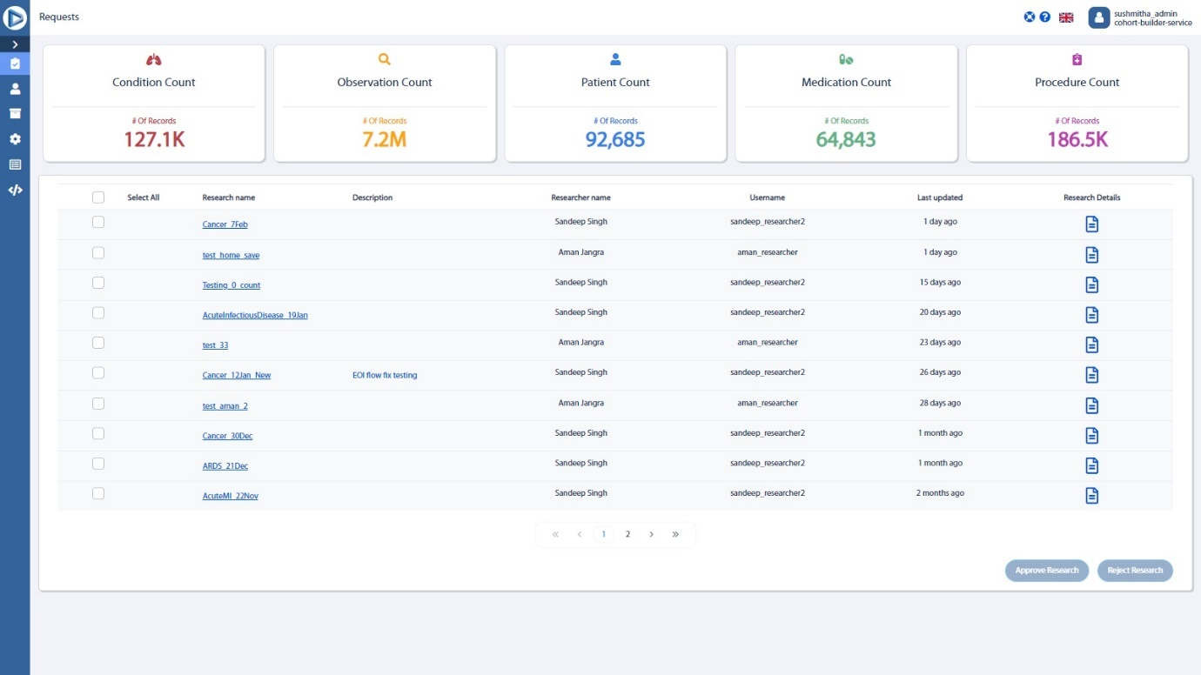

## Field and Button description – Requests page

|  |  |
| --- | --- |
| Name | Description |
| **Condition Analytics** | Any problem, diagnosis or clinical concept identified in a patient. |
| **Medication Statement Analytics** | Drug or ingredient. |
| **Observation Analytics** | Vital signs, clinical findings and Laboratory data. |
| **Patient Analytics** | Demographic information to support administrative procedures. |
| **Procedure Analytics** | Any activity performed on the patient as part of provision of care. |
|  | |
| **Requests** | Provides you the details of the Research sent for approval such as **Research name, Description, Researcher name, Username, Last updated.**  **Note:**  When you select a research whose result count is less than 50 from the Requests page, then the below warning message will be displayed,  ***Due to data privacy, specific details cannot be displayed as the result count falls below 50. However, you can still proceed to send the Cohort.*** |
|  | Clicking this icon allows you to view the **research details**. |
|  | Clicking this allows you to **approve the research**. |
|  | Clicking this allows you to **reject the research**.  **Note:**  When you try to reject the research, a new window will be displayed asking the **Reason for Rejection.** Please provide the reason and click **OK**. |

# Research Page

The **Research page** displays the list of research that has been approved and allows to send the EOI.

**Note:**

The **Research** page is accessible to **Admin Researcher** only.

## Manage the specific research

In the **Research page,** as an Admin researcher, you can view the list of research that has been approved and manage the specific research by performing the following activities based on the configuration:

* View the research details
* Send EOI

### View the research details

You can view the research details.

#### Viewing the research details

1. Click **Research** in the left menu of **T4C Gravity Portal**; displays the **Research page**.
2. Search for the **Research Name**.
3. Click the blue row under **Actions** and select **View**; displays the **Detail Research.**

**Note:**

The below warning message will be displayed if the research result count is less than 50,

***Due to data privacy, specific details cannot be displayed as the result count falls below 50. However, you can still proceed to send the Cohort.***

##### Field and Button description – Research Detail page

|  |  |
| --- | --- |
| Name | Description |
| **Research Detail** | Allows you to view the research details as Geography, Site, Age and Gender distribution. |

### Send EOI

Once the research is approved, you can send the specific research as Expression of Interest (EOI) to data provider to match a cohort to participate in a specific trial.

#### Sending EOI

1. Click **Research** in the left menu of **T4C Gravity Portal**; displays the **Research page.**
2. Click the blue row under **Actions** and select **Send EOI**.

**Note:**

When you select the **Send EOI**, the following pop message will be displayed,

There can be no updates to the Research once it is sent. Do you want to send your Expression of interest request?

1. Click **Send**.

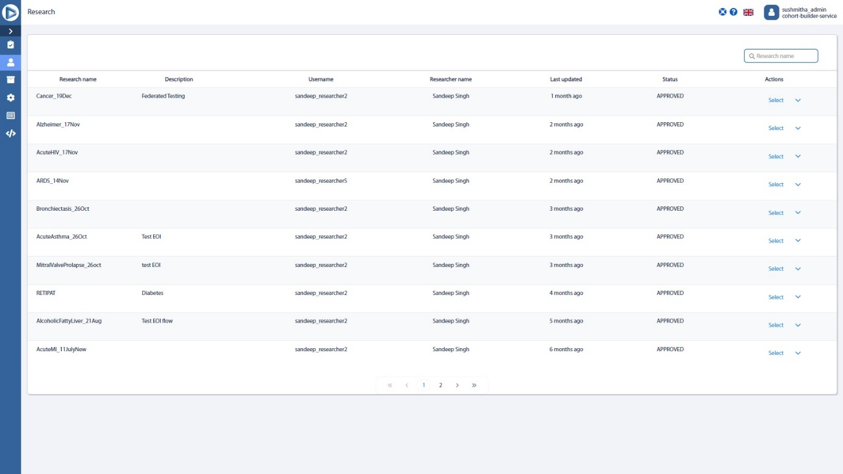

Research page

## Field and Button description – Research page

|  |  |
| --- | --- |
| Name | Description |
| **Research page (Admin Researcher role)** | Displays the list of approved research and allows you to Manage the research within the organization and send EOI.  Displays the details such as **Research name, Description, Username, Researcher name, Last updated, Status, Actions.** |
|  | Clicking this tab allows you to **search for research** from the list. |
|  | Displays the research details of the **Pending requests**. |
|  | This tab allows you to navigate between the **pages**. |

# My Saved Cohorts page

The **My Saved Cohorts page** displays the list of research made.

**Note:**

The **My Saved Cohorts** page is accessible to **Researcher** only.

## Manage the specific research

In the **My Saved Cohorts page,** as a researcher, you can view the list of research made and manage the specific research by performing the following activities based on the configuration:

* View the research details
* Edit the research the details
* Delete the research
* Duplicate the research
* Send for Approval
* Subscribe and Favorite research

### View the research details

You can view the research details.

#### Viewing the research details

1. Click **My Saved Cohorts** in the left menu of **T4C Gravity Portal**; displays the **My Saved Cohorts page**.
2. Search for the **Research Name**.
3. Click the blue row under **Actions** and select **View**; displays the **Detail Research.**

##### Field and Button description – Research Detail page

|  |  |
| --- | --- |
| Name | Description |
| **Research Detail** | Allows you to view the research details as Geography, Site, Age and Gender distribution. |

### Edit the research details

You can edit the research general information such as **Research name, description, and Cohort builder criteria**, and also edit the Research information, and upload files.

**Note:**

You cannot edit the research details if the research is sent for approval.

#### Editing the research details

1. Click **My Saved Cohorts** in left menu of **T4C Gravity portal**; displays the **My Saved Cohorts page.**
2. Click on the top right **search bar** to search a specific research name.
3. Under the **Actions,** click **Edit** to edit research general information or queries included.
4. In this new page you can edit:
   * Research name
   * Research description
   * Cohort builder criteria
5. Click **Go to Cohort builder** to re-apply all criteria.
6. Include any new criteria or edit the existing ones as described in the Perform a query chapter.
7. Click **Update** at the top right of the page.
8. Click **Save or Cancel** to update the perform research results.

##### Field and Button description – Edit Research page

|  |  |
| --- | --- |
| Name | Description |
| **General info tab** | Allows you to edit the **Research name and Description.** |
|  | Clicking this allows you to edit the research query in the Cohort builder page. |
|  | |
| **Research information tab** | Allows you to add the research information. |
|  | Clicking this allows you to add a new Question for specific research. Maximum of 25 questions can be added. You can also mark the question as mandatory, edit the added question and delete it. |
|  | |
| **Upload files tab** | Allows you to view the uploaded files and upload the new files. |
|  | Clicking this allows you to upload a new file. |
|  | Clicking this allows you to cancel uploading the file. |
|  | |
|  | Clicking this allows you to cancel editing the research. |
|  | Clicking this allows you to update the research. |

### Delete the research

You can also delete the research permanently.

#### Deleting the research

1. Click **My Saved Cohorts** in the left menu of **T4C Gravity Portal**; displays the **My Saved Cohorts page**.
2. Search for the **Research Name**.
3. Click the blue row under **Actions** and select **Delete**.
4. Click **Ok** to delete the research permanently.

### Duplicate the research

You can duplicate the specific research.

#### Duplicating the research

1. Click **My Saved Cohorts** in left menu of **T4C Gravity portal**; displays the **My Saved Cohorts page**.
2. Click on the top right **search bar** to search an specific research name.
3. Under the **Actions,** click **Duplicate** to create a copy of this research.

### Send for approval

You can send the research for approval.

#### Sending for approval

1. Click **My Saved Cohorts** in left menu of **T4C Gravity portal**; displays the **My Saved Cohorts page**.
2. Click on the top right **search bar** to search an specific research name.
3. Under the **Actions,** click **Send for approval**; navigates to the Cohort builder page.
4. In the Cohort builder page, view the summary of the research and click **Send for approval**.
5. Answer the questions and click Send. The research will be sent for approval.

##### Field and Button description – Send for approval page

|  |  |
| --- | --- |
| Name | Description |
| **Summary** | Displays the summary of the research such as the Geographical distribution and Integrity checks. |
|  | Clicking this allows you to send the research for approval. |

### Subscribe and Favorite research

You can subscribe the research to receive alerts when the research is updated and add the research as favorite.

#### Subscribing the research and adding the research as favorite

1. Click **My Saved Cohorts** in left menu of **T4C Gravity portal**; displays the **My Saved Cohorts page**.
2. Click on the top right **search bar** to search a specific research name.
3. Click **Subscribe** to receive alerts any time this research is updated.
4. Click **Favorite** to add as favorite in your page.

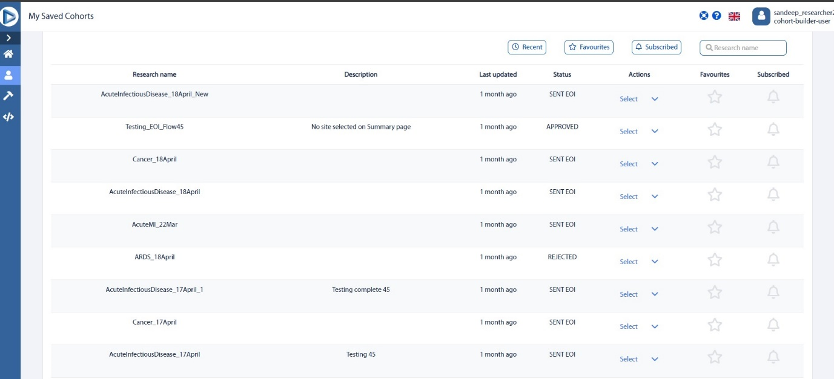

My Saved Cohorts page

## Field and Button description – My Saved Cohorts page

|  |  |
| --- | --- |
| Name | Description |
| **My Saved Cohorts page** | Allows you to Manage **Expression of Interest** within the organization and displays the details such as **Research name, Description, Last updated, Status, Actions, Favourites, Subscribed.** |
| **Research Status** | |  |  | | --- | --- | | Status | Description | | **In progress** | Research is in progress. | | **Sent for Approval** | Research has been sent for approval. | | **Approved** | Research has been approved. | | **Rejected** | Research has been rejected. | | **Sent EOI** | EOI requests sent to Hospitals or other data provider organizations. | |
|  | Clicking this tab will display the details of **recent Research.** |
|  | Clicking this tab will display the details of research that has been added as **favourites.** |
|  | Clicking this tab will display the details of research that has been **subscribed.** |
|  | Clicking this tab allows you to **search for research** from the list. |
|  | This tab allows you to navigate between the **pages**. |

# Research History

This section gives you the details about the EOIs sent. You can also view the research details in a detailed view by clicking View under the Actions column.

**Note:**

The **Research History** page is accessible to **Admin Researcher** only.

## Field and Button description – Research History page

|  |  |
| --- | --- |
| Name | Description |
| **Research History** | Displays the Sent EOI details such as **Research name, Description, Username, Researcher name, Last updated, Status, Actions.** |
| **EOI Status** | |  |  | | --- | --- | | Status | Description | | **View** | You can view the research details as pie charts. | | **Sent EOI** | EOI requests sent to Hospitals or other data provider organizations. | |
|  | Clicking this tab allows you to **search for research** from the list. |

# Logs

This section gives you the details about the logs of the requests that you performed.

**Note:**

The **Logs** page is accessible to **Admin Researcher** only.

## Review internal organization history

You can review the internal organization history such as **Date/Time, Name, Username, and Action** performed.

You can also find the EOI details like Patient ID, Gender, Age, Vital status, Ethnicity, Race, City, and Country if the action performed is **EOI sent**.

### Reviewing the internal organization history

1. Click **Logs** button on the left menu; displays the **Logs page.**
2. Review the information specified:
   1. **Date/Time**: Timestamp of the action.
   2. **User**: Indicates the user who performed the action.
   3. **Action performed**: Contains the description of the action performed. This column will display the actions such as Query executed, Sent for Approval, Research created, Approved, Rejected, Sent EOI and so on.

## Field and Button description – Logs page

|  |  |
| --- | --- |
| Name | Description |
| **Logs** | Displays the activity logs of users and EOI requests such as Date/Time, Name, Username, and Action performed.  You can also find the EOI details like Patient ID, Gender, Age, Vital status, Ethnicity, Race, City, and Country if the action performed is EOI sent. |
|  | Clicking this allows you to view the data of all the pages. |
|  | This allows you navigate between the pages. |

# Documentation

In this section, you can explore a comprehensive guide to navigate through the portal’s features efficiently. And you can also unlock the full potential of the portal with our accessible set of APIs, empowering you to leverage all core functionalities seamlessly.

**Note:**

The **Documentation** page is accessible to both **Researcher** and **Admin Researcher.**

1. Click **Documentation** in left menu of **T4C Gravity portal**.
2. Click **Download file** to save a local version of the user manual.
3. Click **Open file** to open in browser the user manual.

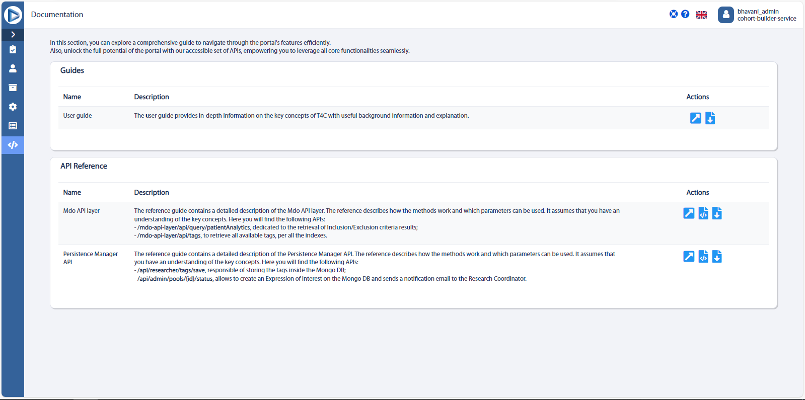

## Field and Button description

|  |  |
| --- | --- |
| Name | Description |
| **Guides section** | This provides in-depth information on the **key concepts of T4C** with useful background information and explanation.  Clicking  allows you to open the file in the browser.  Clicking  allows you to download and save the file. |
|  | |
| **API Reference section** | This reference provides you the detailed description of the Mdo API layer and Persistence manager API and describes how the methods work and which parameters can be used. |

# References

## Generic references

### Top menu buttons

|  |  |
| --- | --- |
| Button | Description |
|  | Contact us |
|  | Favorite query |
|  | Light screen mode |
|  | Dark screen mode |
|  | Profile |

### Languages

|  |  |
| --- | --- |
| Flag | Language |
|  | Italian |
|  | English |
|  | French |
|  | German |

### Left menu

|  |  |  |
| --- | --- | --- |
| Button | Name | Description |
|  | **My EOIs** | Manage Expression of Interest within the organization. |
|  | **Cohort builder** | Create queries and see query search history. |
|  | **Discover** | Search for FHIR specific information |
|  | **Settings** | Manage the user/organization account. |
|  | **Clinalytix NLP Service API** | Natural Language Processing demonstrator to enter clinical text for English and German and generate NLP output |
|  | **Logs** | See activity logs of users and EOI requests |
|  | **Documentation** | Useful information to guide you through the assets of the portal. |

# Appendix

## Glossary

Terms and abbreviations are expanded below and, where applicable, expanded on their first occurrence in the text.

|  |  |
| --- | --- |
| Abbreviation | Description |
| **T4C** | Trials4Care |
| **EOI** | Expression of Interest |
| **API** | Application Programming Interface |
| **NLP** | Natural Language Processing |

## FAQ

***What is an expression of interest?***

*The expression of interest (EOI) is a request sent by an external research organization to data provider to match a cohort to participate in a specific trial.*

***How can I perform searches on available resources?***

*It is possible to perform searches, by typing in any Inclusion/Exclusion criteria in the dedicated page of the portal, i.e. the Cohort builder.*

***Can I create a new user?***

*It is possible to create a new user by accessing the Settings page and typing in all the required information inside the dedicated form. It is important to point out that only users with the Admin Researcher role have the permissions that enable such functionality.*

# Amendment History

|  |  |  |  |
| --- | --- | --- | --- |
| T4C Version | Date | Actioned By | Description |
| *1.0.0* | *25 April 2023* | *Sushmitha D* | *Draft created.* |
| *1.0.0* | *19 June 2023* | *Sushmitha D* | *Updated the* ***Settings and Perform research query sections (removed criteria match score details)*** *for sprint30_alpha-0.1.* |
| *1.0.0* | *11 July 2023* | *Sushmitha D* | *Updated the* ***Settings section*** *for sprint31_alpha-0.1* |
| *1.0.0* | *7 August 2023* | *Sushmitha D* | *Updated the* ***Research and My Research screens*** *for sprint33_alpha-0.1* |
| *1.0.0* | *29 August 2023* | *Sushmitha D* | *Updated for sprint34_alpha-0.2.* |
| *1.0.0* | *05 October 2023* | *Sushmitha D* | *Updated for sprint36_alpha-0.1.* |
| *1.0.0* | *10 November 2023* | *Sushmitha D* | *Updated the* ***Section 5 – Perform research query and section 7 – Expression of Interests (EOI)*** *for sprint37_alpha-0.1.* |
| *1.0.0* | *22 November 2023* | *Sushmitha D* | *Added the* ***Section 8 – Research History*** *for sprint38_alpha-0.1.* |
| *1.0.0* | *08 December 2023* | *Sushmitha D* | *Updated for sprint39_alpha-0.1* |
| *1.0.0* | *08 January 2024* | *Sushmitha D* | *Updated the* ***Section 5 – Perform Research Query – Cohort Builder (updated the screenshots and added about recruitable and non-recruitable data)***  ***Section 4 – Settings (Updated the screenshot)***  ***Section 9 – Logs (Updated the screenshot and field and button description)*** *for sprint40_alpha-0.1.* |
| *1.0.0* | *17 January 2024* | *Sushmitha D* | *Added the* ***My Saved Cohorts*** *section and updated the* ***Cohort Builder*** *section for sprint 41_alpha-0.1.* |
|  |  |  | *No updates for sprint 42 and 43.* |
| *1.1.0* | *26 March 2024* | *Bhavani S* | *Updated the* ***Section 8 - My Saved Cohorts page*** *and* ***Section 5 – Perform Research Query – Cohort Builder*** *and updated the screenshots in* ***Section 4 - Settings*** *for sprint 44_alpha-0.1.* |
| *1.1.0* | *15 April 2024* | *Bhavani S* | *Updated the* ***Section 11 – Documentation, Section 5.4 - Send the research for approval, Section 5.4.1 - Sending the research for approval*** *and* ***Section 5.6 - Field and Button Description – Send for approval in Cohort Builder page*** *for sprint 45_alpha-0.1.* |
| *1.1.0* | *09 May 2024* | *Bhavani.S* | *Updated the* ***Section 8.1.2.1 - Editing the research details****,*  ***Section 6.1.1 - Approving and rejecting the research,***  ***Section 6.2 - Field and Button description – Requests page,***  ***Section 7.1.2.1 - Sending EOI,***  ***Section 3 - Home Page,***  ***Section 3.1.1 - Field and Button description – Home page*** *and*  ***Section 5.3.1 - Modifying and Saving query research*** *(only screens) for sprint 46_alpha-0.1.* |
| *1.1.0* | *28 May 2024* | *Bhavani.S* | *Updated the* ***Section 5.1.1 - Building a new query,***  ***Section 5.5 - Field and Button Description – Cohort Builder page,***  ***Section 7.1.1.1 - Viewing the research details***  ***Section 6.2 - Field and Button description – Requests page*** *for sprint 47_alpha-0.1.* |